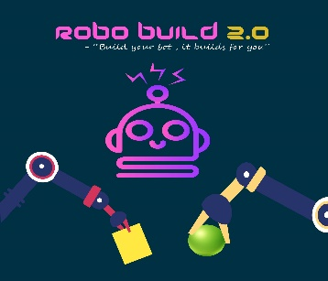 *ROBO BUILD 2.0*

**>> BUILD YOUR ROBO, IT BUILDS FOR YOU**

* INTRODUCTION

Have you ever wanted to own a robot which builds amazing structures for you?

Why not create such a robot yourself !!

We are back with a bigger and better version of RoboBuild under the aegis of

Tecnoesis 2020. A competition where your bots will have to build structures

And at the same time prevent opponent bots from destroying the same.

Gear up for this race of construction and demolition and showcase how

efficient your bot is!

* PROBLEM STATEMENT

Each team will have to build 2 robots: The Builder and The Helper. As the

names suggest, the Builder is going to construct the structure whereas the

Helper is going to perform 3 tasks: a) attack opponent’s structure b) defend

Your structure c) help in fetching blocks for the structure during the game.

* GAME PLAY

TOTAL TIME FOR ONE MATCH: 12 MINUTES

Two teams will be competing against each other in a match. Blocks of various shapes will be spread around on the arena. The blocks will be of two different colours representing the 2 teams. Each team will be allotted one colour and they have to build their structure using blocks of that particular colour only. The Helper bot of each team will be collecting the blocks and bringing them in close proximity of the Builder bot (as the later will be immobile). The Builder will grab the blocks with its arm and place them on top of each other to form a structure.

Points will be allotted for each block you use in your structure. Marks will be allotted on the basis of the shapes of blocks as well as the level in which you use them. The marks distribution is as follows:

|  |  |  |  |  |
| --- | --- | --- | --- | --- |
| **SHAPES** | **GROUND LEVEL** | **1ST LEVEL** | **2ND LEVEL** | **3RD LEVEL** |
| **CUBOID** | 10 | 10 × 1.5 | 10 × 2 | 10 × 2.5 |
| **CUBE** | 20 | 20 × 1.5 | 20 × 2 | 20 × 2.5 |
| **FRUSTRUM** | 50 | 50 × 1.5 | 50 × 2 | 50 × 2.5 |
| **SPHERE** | 100 | 100 × 1.5 | 100 × 2 | 100 × 2.5 |

And so on…..

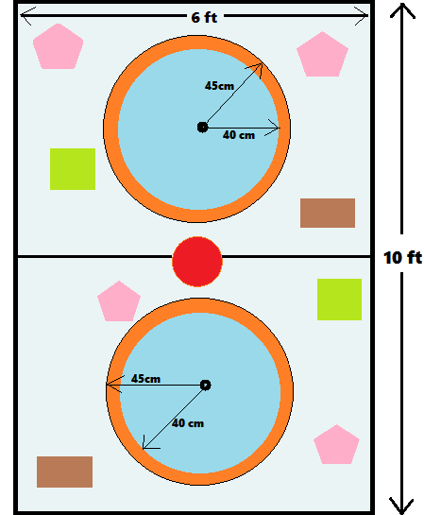

After the 6th minute the Helper bot will be allowed to enter the opponent’s region and try to demolish their structure. A total of 1.5 minutes will be allotted for the demolition task, at the end of which the Helper should cease its actions and return to its own region. Any action of demolition after the stipulated 1.5 minutes will be considered as a foul and result in deduction of marks.

At the 9th minute a mighty sphere and a container will be added to the arena. The team which will be able to grab the sphere and put it inside the container will be given a bonus of 50 points.

At the end of 12 Minutes, the team having higher score will be declared as winner.

In case of a tie, the team having more levels in its structure will be declared as winner. In case there is a tie and none of the teams could build a structure having more than one level, then the highest sum of the 6 blocks in the ground floor present inside the circle will be taken into consideration.

* RULES AND REGULATIONS
* One player will control the Builder and another player will control the Helper. There may be another assistant outside the main arena to control the wires etc.
* During the gameplay, the players will not be allowed to touch the bots. They are only allowed to touch the controllers.
* If the Helper brings blocks of the opponent team into its own arena, it will be considered as a foul. Half of the marks associated with that block will be deducted from the total score of the concerned team.
* If a bot goes immobile for more than a minute, the team will be a given a total of 3.5 minutes to repair it. If the team is unable to repair their bot within the given time, they may get disqualified.
* The bots should in no way damage the arena.
* The blocks will be added as per co-ordinator’s jurisdiction and is not questionable.
* SPECIFICATIONS

**BOT SPECIFICATION:**

1. Builder bot: Maximum dimensions = 25cm*25cm*20cm (l*b*h)

( including wheels)

Maximum radius of arm = 40cms.

1. Assistive bot: Maximum dimensions = 25cm*25cm*20cm (l*b*h)

( including wheels)

Maximum radius of the arm = 40cms.

1. Maximum weight ( per bot ) = 4.5kg
2. Wheel width = 2cm
3. Use of ready-made kits and ready-made mechanical grippers are not

allowed.

1. The potential difference between any two points in the bot should not

Exceed 12 Volts.

1. The bot must be controlled by wired or wireless remote-control mechanism

throughout the game.

1. 220VAC power supply will be provided by the organisers*.*

**ARENA SPECIFICATION:**

1. Dimensions = 10ft*6ft (l*b)

2. Radius of circle where the tower is to be built = 40cms.

**TOWER SPECIFICATION:**

• Ground Floor: Maximum 6 blocks

• First Floor: Maximum 5 blocks

• Second Floor: Maximum 4 blocks

• Higher floors have no restriction on the number of blocks present.

**TEAM SPECIFICATION:**

1. Each team may have a maximum 5 members.

2. Participants from different educational institutes can form a team.

**EQUIPMENTS TO BE PROVIDED BY ORGANISERS:**

* 4 motors @ 400rpm
* 1 motor @ 60rpm
* 1 motor @ 200rpm
* Rainbow wires 5 metres
* 3 DPDT Switches
* ENTRY FEES

• **If participating as a team** : ₹2500 (maximum of 5members in a team)

**• If participating as an individual**: ₹500 (individuals will be grouped together by organisers to form teams)

• **If components for building bots are not required**: ₹250 (individual/team)

* ORGANISERS

• Rituraj Kumar (6200002633)

• Abhishek Aman (9660768136)

• Shivam (6387561485)

• Nirmita Biswas (8134999696)

• Anuva Bhattacharjee (6000079319)